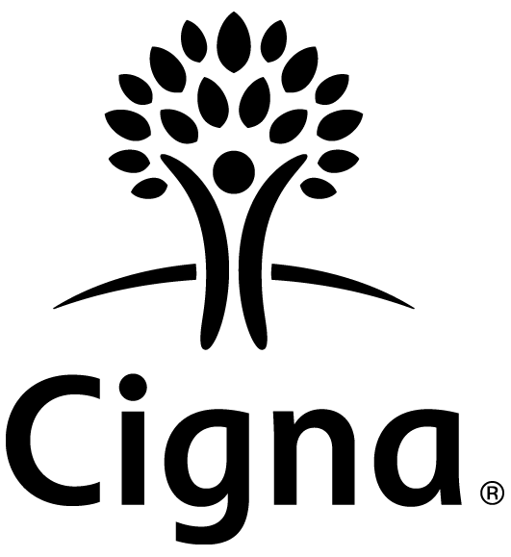Cigna dental plans are insured and/or administered by: Cigna Health and Life Insurance Company Connecticut General Life Insurance Company
Cigna Dental Care*
For mailing address, call Customer Service at the telephone number listed on your Cigna ID card.

$0.00

Cat. #590154f Rev. 12/2013
Clear Fields

