VEHICLE PURCHASE ORDER

PURCHASER'S
NAME -
PLEASE ENTER MY ORDER FOR ONE ---------- D NEW D USED D DEMO AS FOLLOWS

COLOR
TYPE
I YEAR
MILEAGE
TO BE DELIVERED ON OR ABOUT
LICENSE
TRANSFER
TITLE
REGISTRATION FEE
(1) TOTAL CASH SALE PRICE
z
w
:!!:
>
<(
D..
z
;:
0c
CASH DEPOSIT SUBMITTED WITH ORDER
ALLOWANCE FOR USED VEHICLE TRADE-IN
LESS BALANCE OWING TO -
BALANCE DUE (1 less 2)
MAKE
IMODEL
VEHICLE IDENTIFICATION NUMBER
PRICE OF VEHICLE
TOTAL
TAX DEALER DOCUMENTARY FEE
DESCRIPTION OF TRADE I VIN
I (2) TOTAL DOWN PAYMENT
YEAR
!MAKE
I MODEL
! TYPE
MILEAGE
I PLATE NO.
I EXP. DATE
Purchaser intends to use the vehicle primarily for D personal, family, or household purposes ("personal use") D business, agricultural or other non-personal uses ("commercial use").
Purchaser agrees that this Order includes all of the terms and conditions on both the face and reverse side hereof, that this Order cancels and supersedes any prior agreement and as of the date hereof comprises the complete and exclusive statement of the terms of the agreement relating to the subject matters covered hereby. This Order is not binding until accepted by Seller and, if a time sale, (1) appropriate financing disclosures are made and (2) a retail installment sale contract and purchase money security agreement ("Contract") is executed. Until a time sale Order becomes binding, Purchaser may cancel it and recover any deposit made. The Contract and this Order shall be subject to cancellation by Seller unless and until approval of the Contract is given by a bank or finance company willing to purchase the Contract from Seller.
LIMITATIONS/EXCLUSIONS OF PRODUCT WARRANTIES
(a) For "new" vehicles: (1) If the vehicle is purchased for personal use, Seller makes no implied warranty of merchantability or of fitness for any particular purpose unless Seller also gives Purchaser a written warranty, on its own behalf, with respect to the Vehicle, or, at the time of the sale or within 90 days thereafter, Seller enters into a service contract with Purchaser which applies to the vehicle. In that event, any implied warranties arising from the sale of the vehicle shall be limited to duration of Seller's written warranty or service contract; (2) If the vehicle is purchased for commercial use, Seller makes no implied warranty of merchantability or of fitness for any particular purpose. The vehicle is sold to Purchaser AS IS, except for any express warranties made by Seller, on its own behalf, or by the manufacturer of the Vehicle or of any component parts. (3) In all cases, Seller shall not be liable for any consequential damages arising from any breach of any warranty, express or implied.
- For 11 used11 vehicles:

Used Car I mplied Warranty of Merchantability:
THE SELLER HEREBY WARRANTS THAT THE VEHICLE WILL BE FIT FOR THE ORDINARY PURPOSES FOR WHICH THE VEHICLE IS USED FOR 15 DAYS OR 500 MILES AFTER DELIVERY, WHICHEVER IS EARLIER, EXCEPT WITH REGARD TO PARTICULAR DEFECTS DISCLOSED ON THE FIRST PAGE OF THIS AGREEMENT. YOU (THE PURCHASER) WILL HAVE TO PAY UP TO $25.00 FOR EACH OF THE FIRST TWO REPAIRS IF THE WARRANTY IS VIOLATED.
  - Waiver of Used Car I mplied Warranty of Merchantability:
ATTENTI ON PURCHASER: SIGN HERE ONLY IF THE DEALER TOLD YOU THAT THIS VEHICLE HAS THE FOLLOWING PROBLEM(S) AND THAT YOU AGREE TO BUY THE VEHICLE ON THOSE TERMS:
ATENCI ON COMPRADOR: FIRME AQUI SOLAMENTE SI EL VENDEROR TO HADICHO QUE EL VEHICULO TIENE EL SIGUIENTE PROBLEMA(S) Y QUE USTED ESTA DE ACIERTO DE COMPRA EL VEHICULO BAJO ESTOS TERMINOS:

1. -
2. -
3. -
Buyer/Comprador _ BuyedComprador --------------

(3) The vehicle is sold "AS IS - - NOT EXPRESSLY WARRANTED OR GUARANTEED" unless Seller gives Purchaser a separate written instrument showing the terms of any warranty or service contract given by Seller on its own behalf. If the vehicle is purchased for personal use, Seller makes no implied warranty of fitness for any particular purpose, and the implied warranty of merchantability is limited to 15 days or 500 miles after delivery, whichever is earlier, as set forth above, unless Seller also gives Purchaser a written warranty, on its own behalf, with respect to the Vehicle, or, at the time of the sale or within 90 days thereafter, Seller enters into a service contract
with Purchaser which applies to the Vehicle. In that event, any implied warranties arising from the sale of the vehicle shall be limited to the duration of Seller's written /
warranty or service contract. If the vehicle is purchased for commercial use, Seller makes no implied warranty of fitness for any particular purpose, and the implied warranty of merchantability is limited to 15 days or 500 miles after delivery, whichever is earlier. In all cases, Seller shall not be liable for any consequential damages arising from any breach of any warranty, express or implied, except for a breach of the implied warranty of merchantability.
Purchaser, by execution of this Order, represents that Purchaser is of legal age or older and acknowledges that Purchaser has read its terms and conditions and has received a true copy of this Order.
NOTICE: WHERE THE DEALER ARRANGES FINANCING, THE DEALER MAY RECEIVE A PORTION OF THE 11 FINANCE CHARGE 11 FROM THE LENDER.
Signed: PURCHASER

Signed: PURCHASER SALESPERSON

Approved _
THIS ORDER IS NOT VALID UNLESS SIGNED AND ACCEPTED BY SELLER.
Address: ------------------

By _ Phone (Res): (Bus.) _

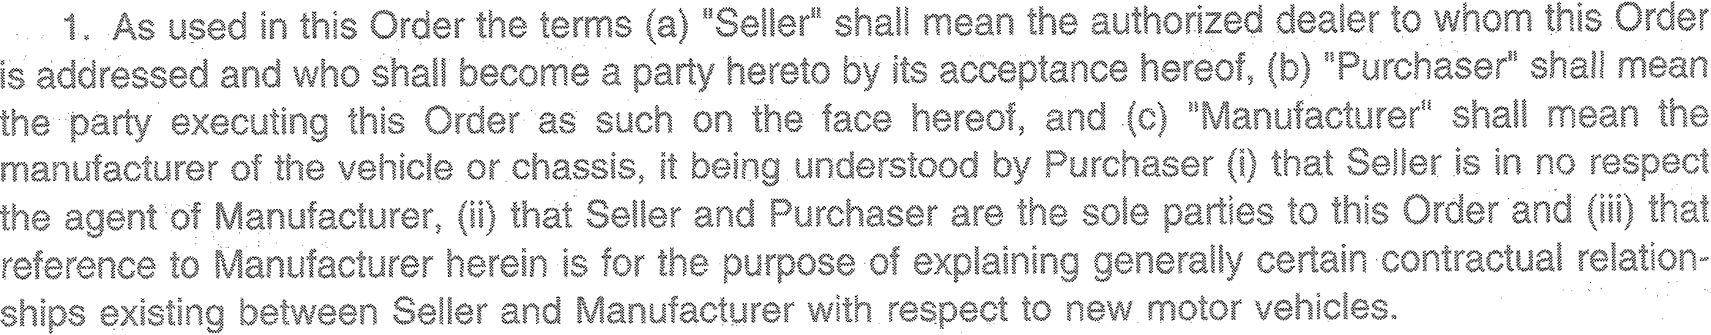

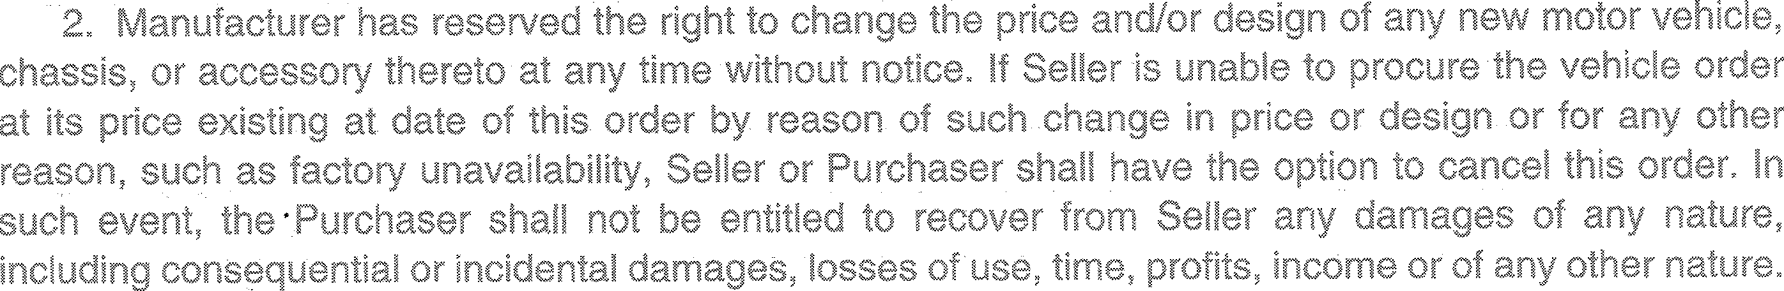

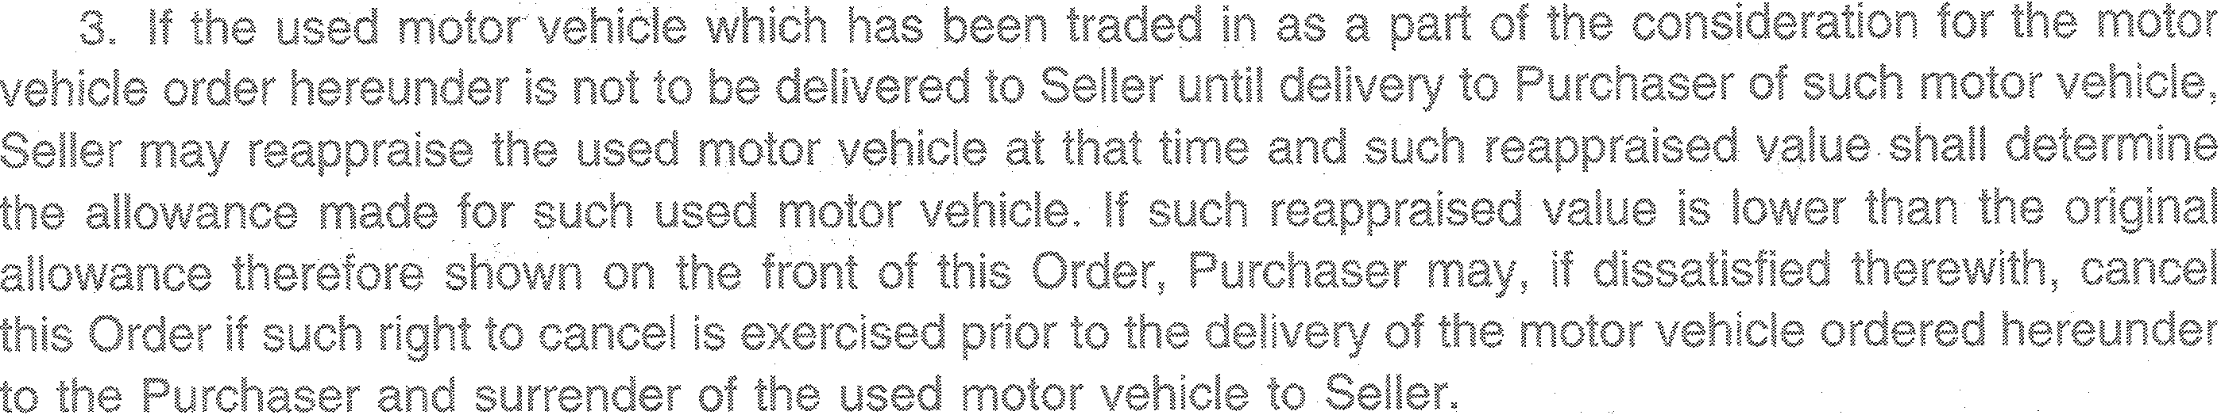

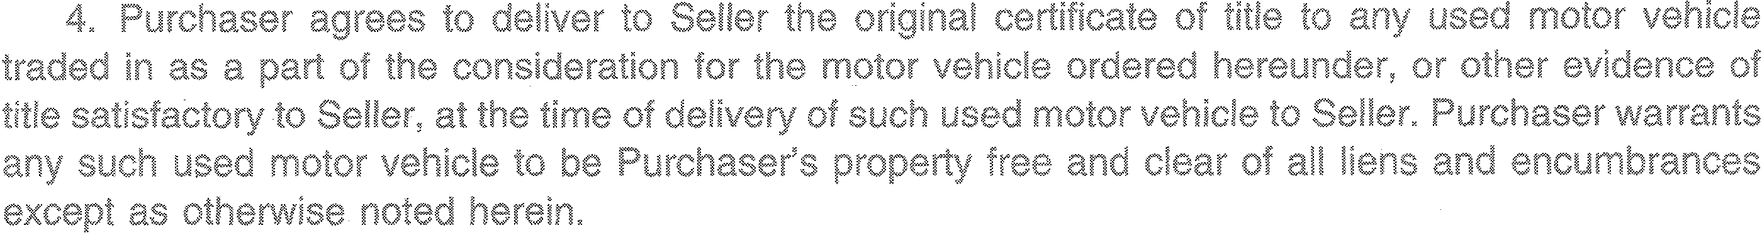

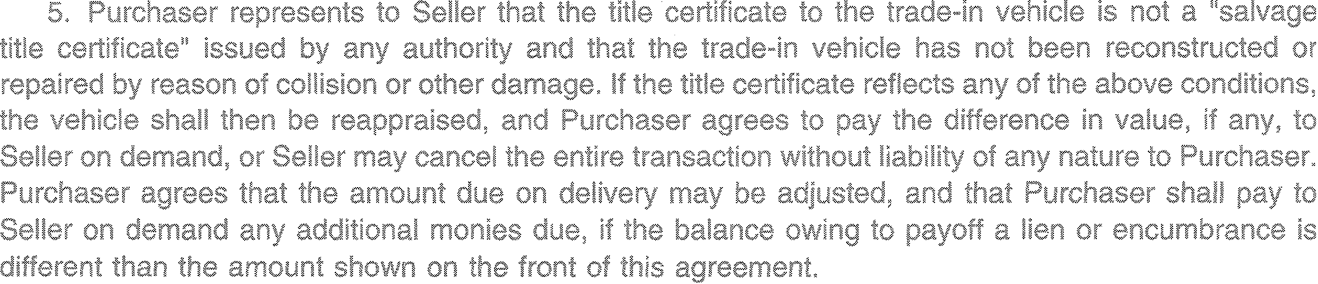

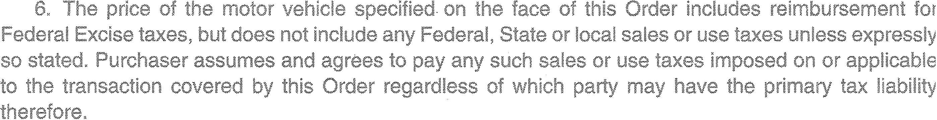

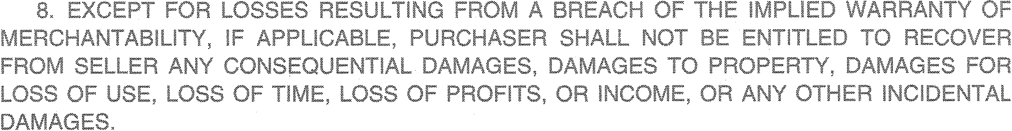

1
If
in

