General Forbearance Request OMBNo. 1840-0725 FormApproved
William D. Ford Federal Direct Loan Program Exp. Date 12/31/99
Federal Direct Stafford/Ford Loans, Federal Direct Unsubsidized Stafford/Ford Loans, Federal Direct PLUS Loans, Federal Direct Consolidation Loans
WARNING: Any personwhoknowingly makesa falsestatement ormisrepresentationon this form shall besubject GFB
to penaltieswhichmay includefines, imprisonment or both, under theU.S. Criminal Codeand20U.S.C. 1097. General
Borrower's Information |  |  | Pleaseprint.
Last Name | First Name | Middle Initial | Social Security Number
StreetAddress |  |  | HomeAreaCode/TelephoneNumber  ( )
City | State | Zip Code
 |  |  | 123456789012345678901234567890121234567890123456789012345678901
Section1: ForbearanceRequest |  |  | Must be completed by borrower.
Forbearancemeansan arrangement to postponeor reducethe amount of a borrower's monthly payment for a limited and specific ti me period. The borrower is charged interest during a forbearance. A forbearanceis available to a borrower or an endorser who is willing but unable to ma ke currently scheduled Direct Loan payments dueto a temporary financial hardship.

To request a forbearance, please complete the items below, sign and date this form, and return it to the Direct LoanServicing Center. (Pleasenote th at all referencesto "borrower" apply to anendorser ona Federal Direct PLUSLoan.)
I amwilling but unable tomakemy current Direct Loanpayments dueto a temporary financial hardship. If this forbearanceis approved, I chooseto (checkone):
❏ temporarily stopmakingpayments; ❏ makesmaller payments thanpreviously scheduled. Iwould like to pay$ permonth.

I am requestingthis forbearancebecause:

I am requesting that theU.S. Department of Education (ED) grant a forbearanceonmy loan(s) beginning (MM-DD-YY) andending

(MM-DD-YY) for a period not to exceedoneyear. At the endof oneyear, I may reapply to renew the forbearanceif I am still ex periencing financial hardship.

Borrower Understandings andCertifications

I understandthat: (1) I will continueto receivebillingstatements formy current payment amount which I must payuntil I am notifiedby theD irect LoanServicingCenter that my forbearancerequesthasbeengranted; (2)EDwillnotgrant thisforbearancerequestunlessall itemsonthisformarecomplete dandanyadditional requireddocumentationisprovided; (3)duringtheforbearanceperiod,principalandinterestpaymentsmaybeforborne,butinterestwillcontinuetoaccruewhethe rornotmyloan(s)issubsidizedbythefederalgovernment;
(4) if I requesteda temporary suspensionof payments, Iwill receivea quarterly statement detailing the interest that hasacc ruedduring theprior period, andunlessI chooseto pay this interest, EDwill addthe interest to the principal balanceof my loan(s) at the endof the forbearanceperiod (this is ca lled capitalization); (5) if I requested a reducedpayment forbearance, I will receivea monthly bill for the requestedpayment amount until the forbearanceends, andanyunpaid interest that hasaccruedduring theperiodwill beaddedto theprincipal balanceof my loan(s) (capitalized) at theendof the forbearanceperiod.
I certifythat: (1)TheinformationI haveprovidedaboveis trueandcorrect; (2) Iwill provideadditional documentation, asrequired, toE Dtosupportmycontinuedforbearancestatus;
(3) I will notify EDimmediately whenthecondition(s) that qualifiedme for the forbearanceends; (4) I haveread, understand, andmeet the terms andconditionsof the forbearance for which I haveapplied; and(5) I agree, uponterminationof this forbearance, to repaythis loanaccording to the terms of m y promissory note andrepayment schedule.

Signature of Borrower: Date:

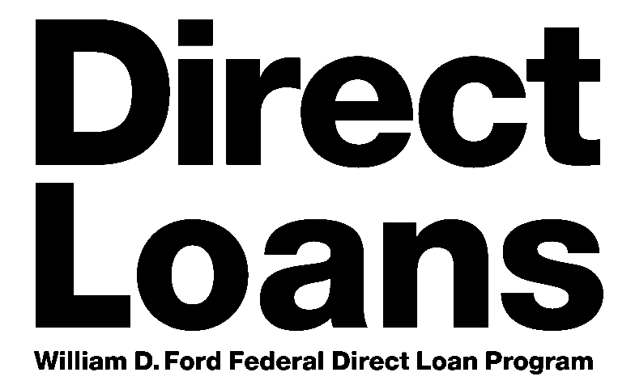GFB(SCH)

Revised 6/97

Important Notices
PrivacyAct Disclosure Notice

ThePrivacyAct of 1974(5 U.S.C. 552a) requires that wediscloseto youthefollowing information:

Theauthorityforcollectingthisinformationis§451et seq.oftheHigherEducationActof1965,asamended(theHEA)(20U.S.C.§1087a et seq.). Theprincipalpurposeforcollecting this informationis to determinewhether youare eligible fora forbearanceonyour loan(s) under theWilliamD. Ford Federal D irect Loan(Direct Loan) Program.

We askthat youprovidetheinformationrequestedonthis Direct Loanforbearanceformona voluntary basis. However, youmust provideall of therequestedinformationthat is available to yousotheDepartment candeterminewhether youqualify for a forbearance.

Theinformationinyour filemaybedisclosedto thirdpartiesasauthorizedunder routineusesin thePrivacyAct noticescall ed“Title IVProgramFiles” (originallypublishedonApril 12, 1994, Federal Register, Vol. 59, p. 17351) and“National Student LoanDataSystem” (originally publishedonDecember 20, 1994, Federal Register, Vol. 59, p. 65532). Thus, this informationmaybedisclosedto parties that we authorize to assist us in administering theFederal student aidprograms, including contractors that are required tomaintain safeguards under thePrivacyAct. Disclosuresmay also bemadefor verification of information, determination of eligibility, enforcement of conditionsof the loanor grant, debt collection, andthepreventionof fraud,waste, andabuseandthesedisclosuresmaybemadethroughcomputermatchingprograms withotherFederal agencies. Disclosuresmay bemadetodeterminethefeasibilityof enteringintocomputermatchingagreements. Wemaysendinformationtomembersof Cong ressif youasktheminwritingtohelpyouwith Federal student aid questions. If weare involvedin litigation, wemaysendinformation to theDepartment of Justice (DOJ), a court, adjudicativebody, counsel, orwitnessif the disclosure isrelatedtofinancial aidandcertainotherconditionsaremet. If thisinformation,eitheraloneorwithother i nformation, indicatesapotential violationof law,wemaysend ittotheappropriateauthorityforconsiderationofactionandwemaydisclosetoDOJtogetitsadvicerelatedtotheTitleI V,HEAprogramsorquestionsundertheFreedomofInformation Act. DisclosuresmaybemadetoqualifiedresearchersunderPrivacyActsafeguards. Insomecircumstancesinvolvingemploymen tdecisions,grievances,orcomplaintsorinvolving decisionsregardingthelettingof a contract ormakingof agrant, license, orother benefit, wemaysendinformationto anap propriate authority. In limitedcircumstances, wemay discloseto a Federal labor organizationrecognizedunder 5 U.S.C. Chapter 71.

Becausewe request your social securitynumber (SSN),wemust informyouthatwecollect yourSSNonavoluntarybasis, but sec tion484(a)(4)of theHEA(20U.S.C. 1091(a)(4)) providesthat, inorder toreceiveanygrant, loan, orworkassistanceunderTitle IVof theHEA, astudentmust providehisor herSSN. YourSSNisusedtoverifyyour identity, and asanaccount number (identifier) throughout the life of your loan(s) sothat datamayberecordedaccurately.

Paperwork Reduction Notice

According to the Paperwork Reduction Act of 1995, no persons are required to
respondto a collection of information unless it displays a currently valid OMB Returnthisformandanyrequired
control number. The valid OMB control number for this information collection is
1840-0725. Thetime required to complete this information collection is estimated documentationto theDirect LoanServicing
to average 0.2 hours (12 minutes) per response, including the time to review Center. If youneedto confirm theDirect instructions, searchexistingdata resources, gather andmaintain thedata needed, LoanServicingCenter’s addressor require andcomplete andreview the information collection. If youhaveanycomments assistancewith completingthis form, call
concerning the accuracy of the time estimate(s) or suggestions for
improving this form, please write to: U.S. Department of Education, 1 (888) 447-4460.
Washington, DC 20202-4651. If you have any comments or concerns regarding the status of your individual submission of this form, write directly to the Direct LoanServicing Center. If you need to confirm the Direct LoanServicing Center’s address, call 1 (888) 447-4460.

